Task
Q1)Crete a iam user and attach the full Administratoracces policy
Step 1) = go to I am service and open this service.

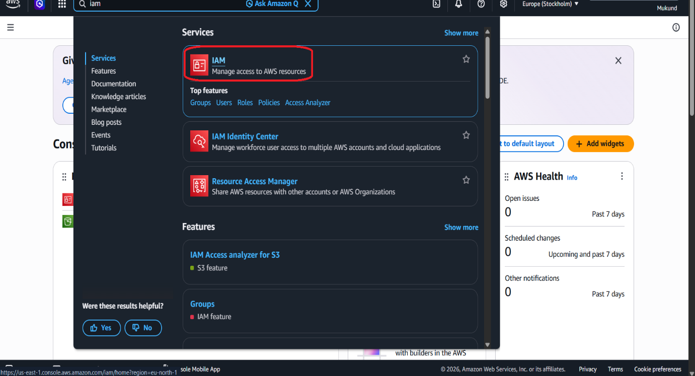

Step 2) = click on I am user
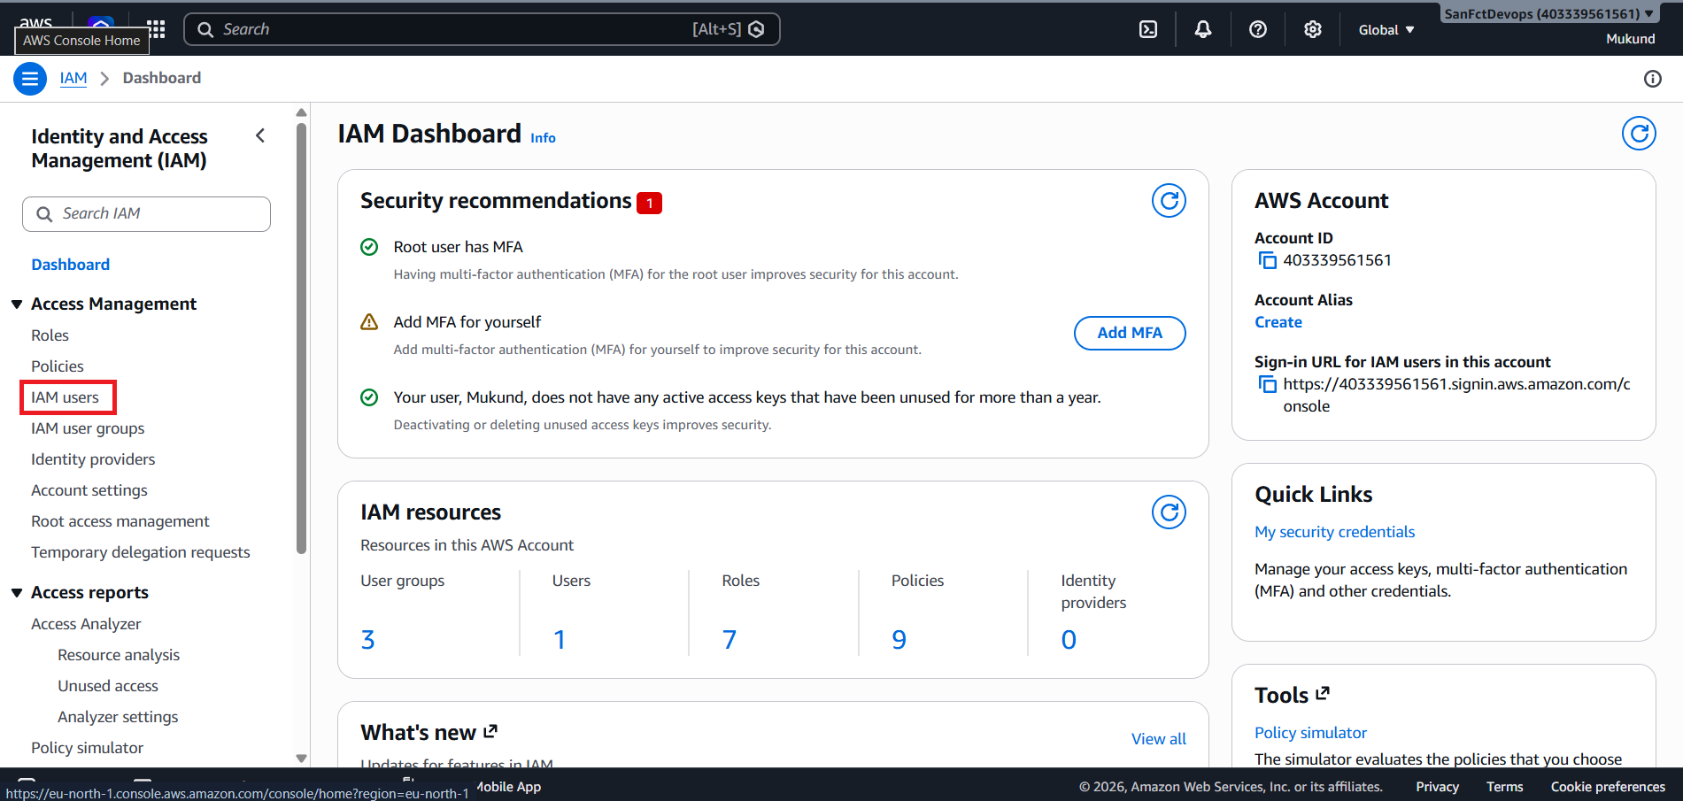
Step 3) = click on create user
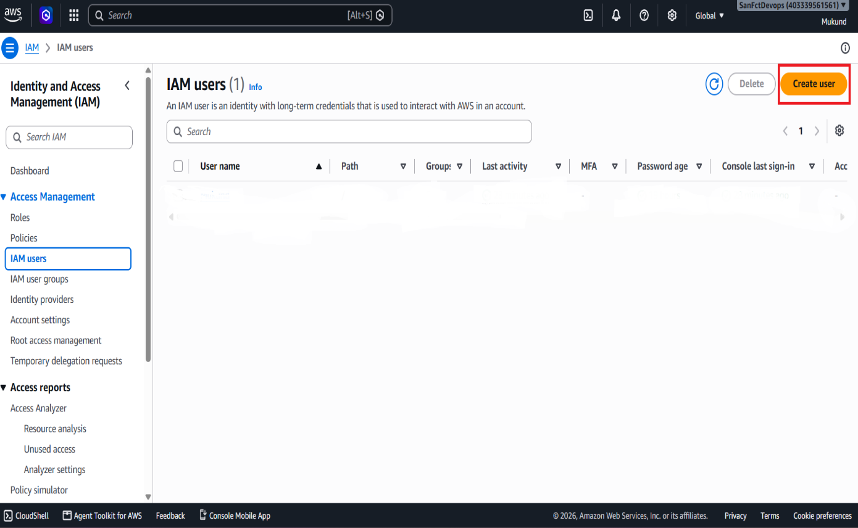

Step 4) = fill the information about user (name,password,)
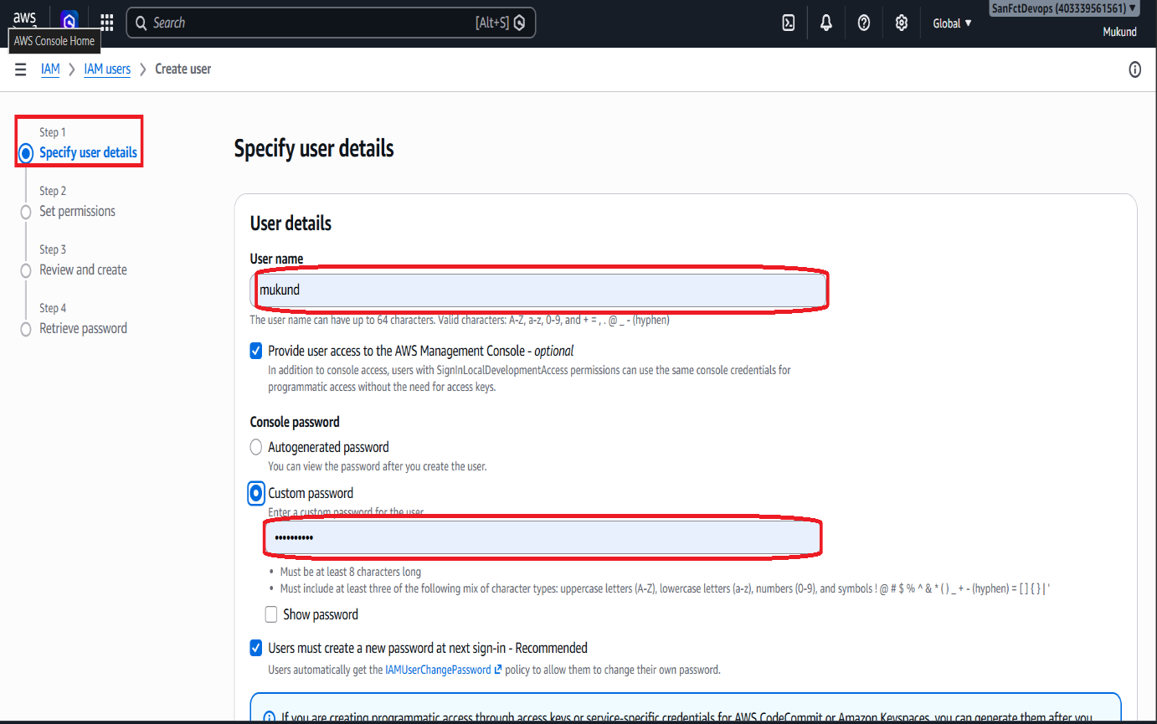

Step 5) = click Attach policies directly and select Administratoracces policy

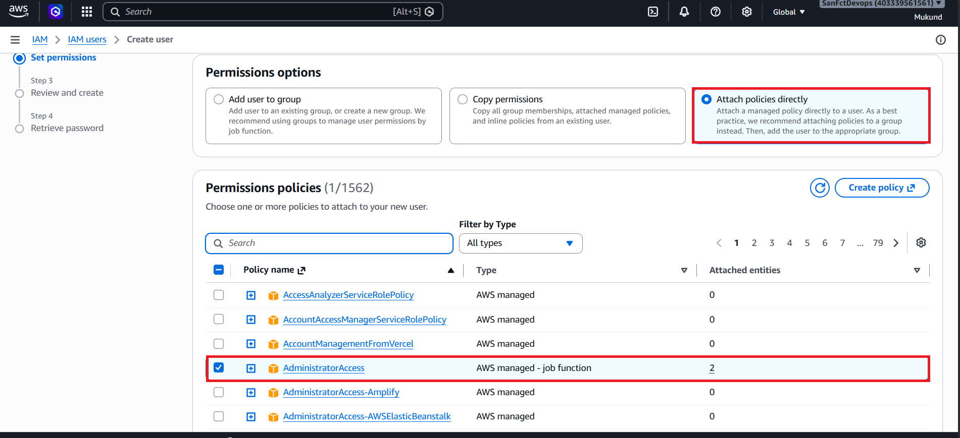

Step 6) = chack your all information is correct then create user

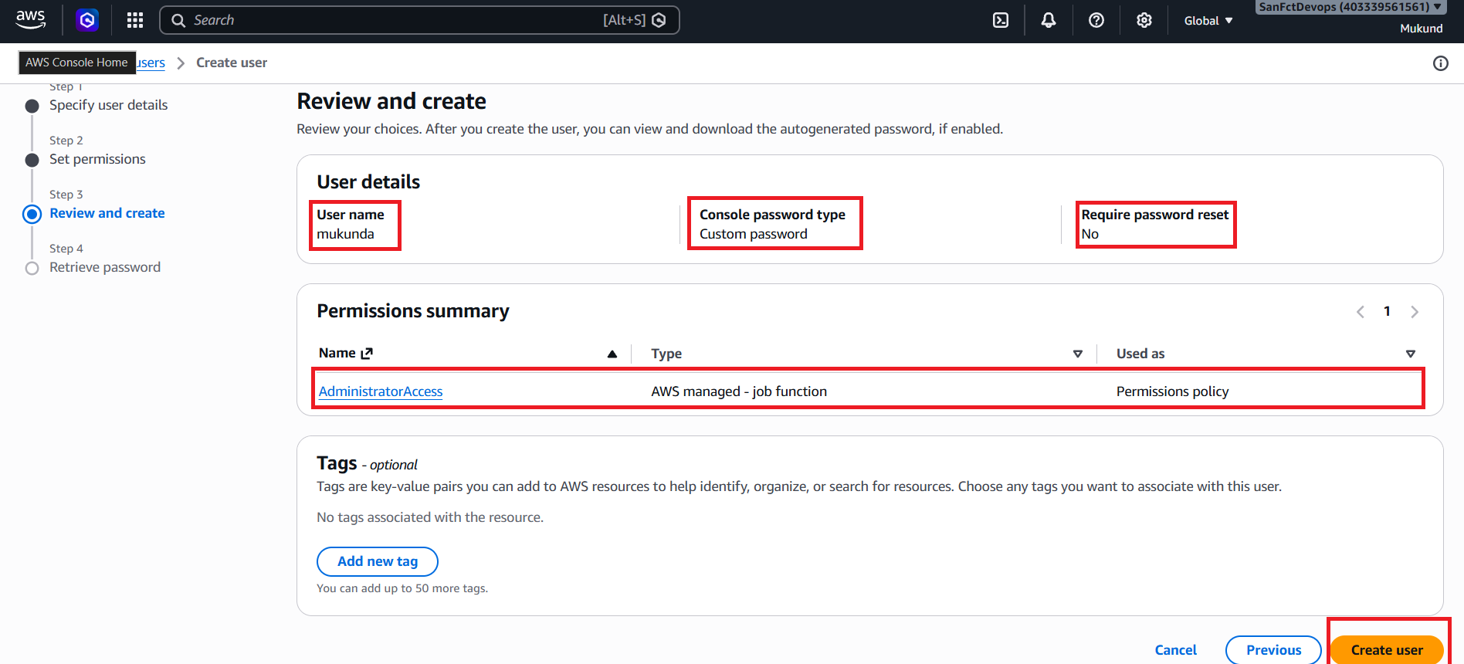
Step 7) = download.csv file because your user credential are save in this file, then return to user list
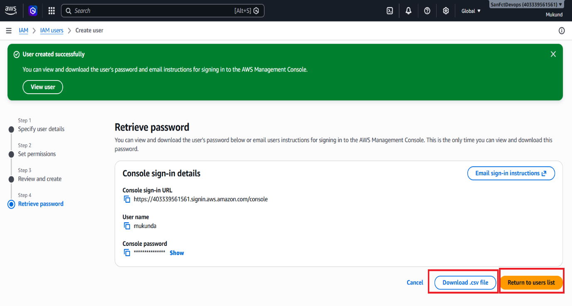

Step 8) =finally see your I am user is created

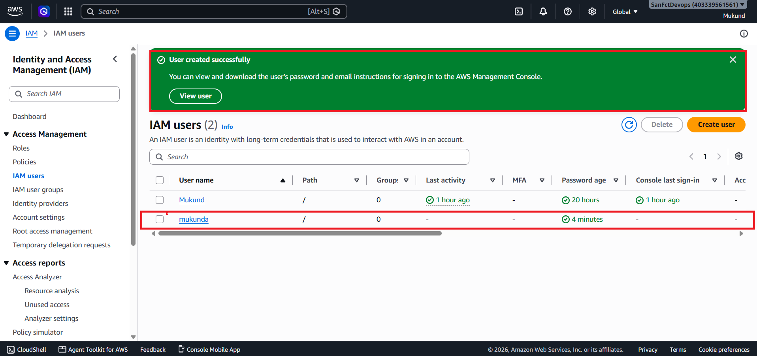
Thank you

